**Phase 8: Data Management & Deployment for EV Charging CRM**

Goal: Manage data efficiently and move configurations from Sandbox to Production.

**1. Data Import Wizard**

Import 50 demo Charging Station records.

Import 50 demo EV Charging Session records.

Steps:

1. Go to Setup → Data → Data Import Wizard.

2. Select object: Charging Station / Charging Session.

3. Upload CSV files.

4. Map fields and start import.

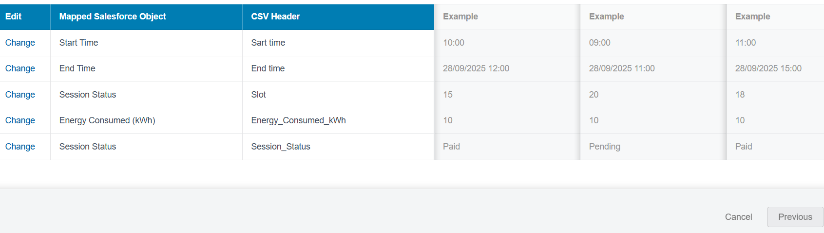

**2. Data Loader**

Bulk import Bookings, Users, and Payment records.

Steps:

1. Open Data Loader → Insert.

2. Select object: Booking / User / Payment.

3. Browse CSV file.

4. Map fields and click Finish.

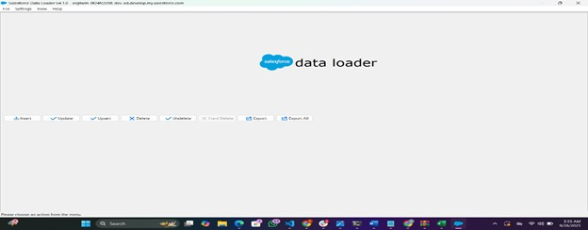

**3. Duplicate Rules**

Prevent duplicate Charging Station entries.

Steps:

1. Setup → Duplicate Rules.

2. Create new rule for Charging Station object.

3. Define matching criteria (e.g., Station Name + Location).

4. Activate rule.

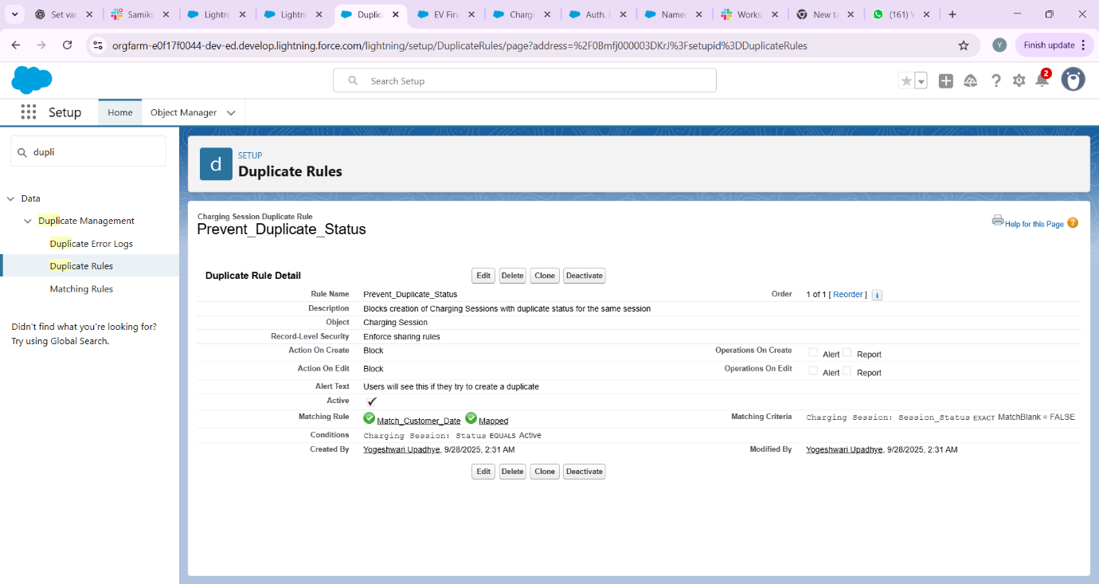

**4. Data Export & Backup**

Weekly backup of all CRM data.

Steps:

1. Setup → Data → Data Export.

2. Schedule export weekly.

3. Download exported files and save securely.

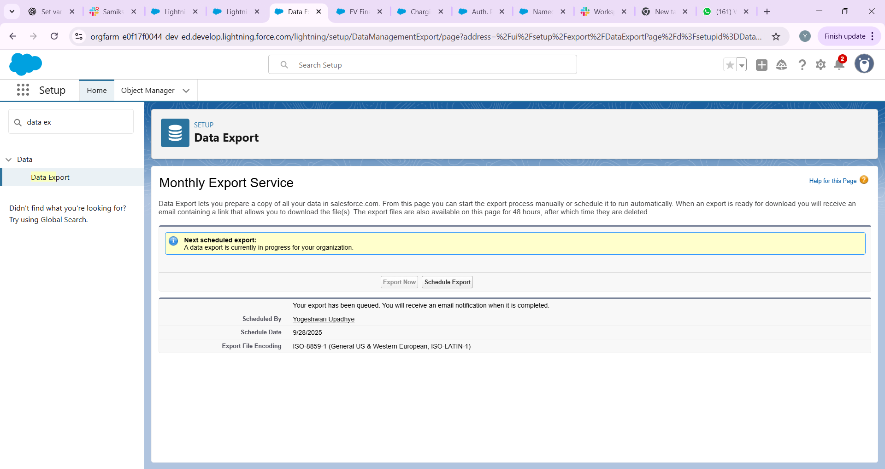

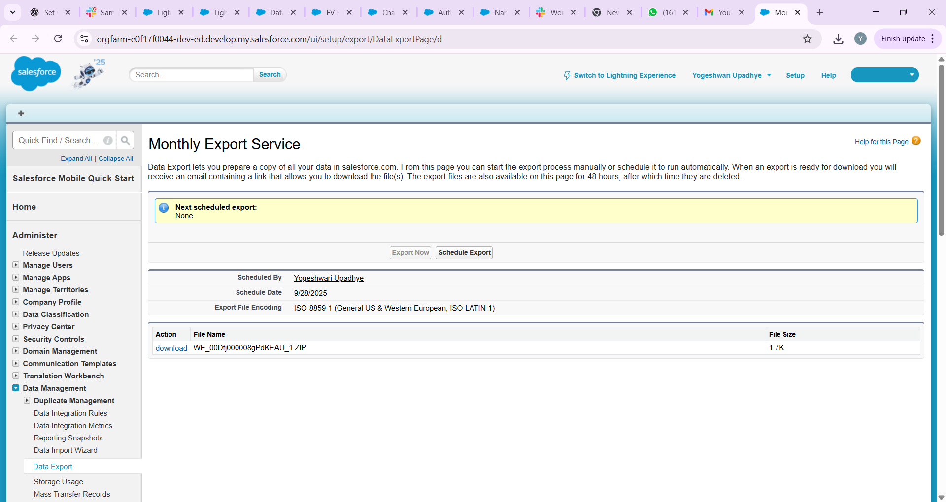

**5. Change Sets**

**Purpose:** Move metadata/configurations from **Sandbox → Production** safely.

**Steps:**

1. Setup → **Outbound Change Sets**.
2. Click **New** → Give a name (e.g., EV_Charging_Release_1).
3. Add **Components**: Objects, Fields, Flows, Validation Rules, etc.
4. Click **Upload** → Select the **Production org**.
5. Login to Production → **Inbound Change Sets** → Review → Deploy.

**Use Case:**

* Deploy your **Charging_Session__c object, flows, and validation rules** from Sandbox to Production without manual re-creation.

**6: Unmanaged vs Managed Packages**

**Purpose:** Package your Salesforce configurations for deployment or distribution.

**Details:**

* **Managed Package:** For publishing on **AppExchange**. Adds versioning and protection.
* **Unmanaged Package:** For **internal deployment** within your org.

**Use Case:**

* If you want your **EV Charging CRM app** for internal testing across multiple orgs → use **Unmanaged Package**.
* If you plan to **sell or share publicly** → use **Managed Package**.

**7. ANT Migration Tool**

**Purpose:** Command-line deployment for bulk metadata migration between Salesforce orgs.

**Steps:**

1. Configure **build.xml** and **package.xml** with metadata components.
2. Use commands:
   * ant retrieve → fetch metadata from source org
   * ant deploy → deploy to target org
   * ant validate → test deployment without committing
3. Review log files for success/failures.

**Use Case:**

* Move **multiple objects, flows, and validation rules** from Sandbox → Production efficiently, especially for large orgs.